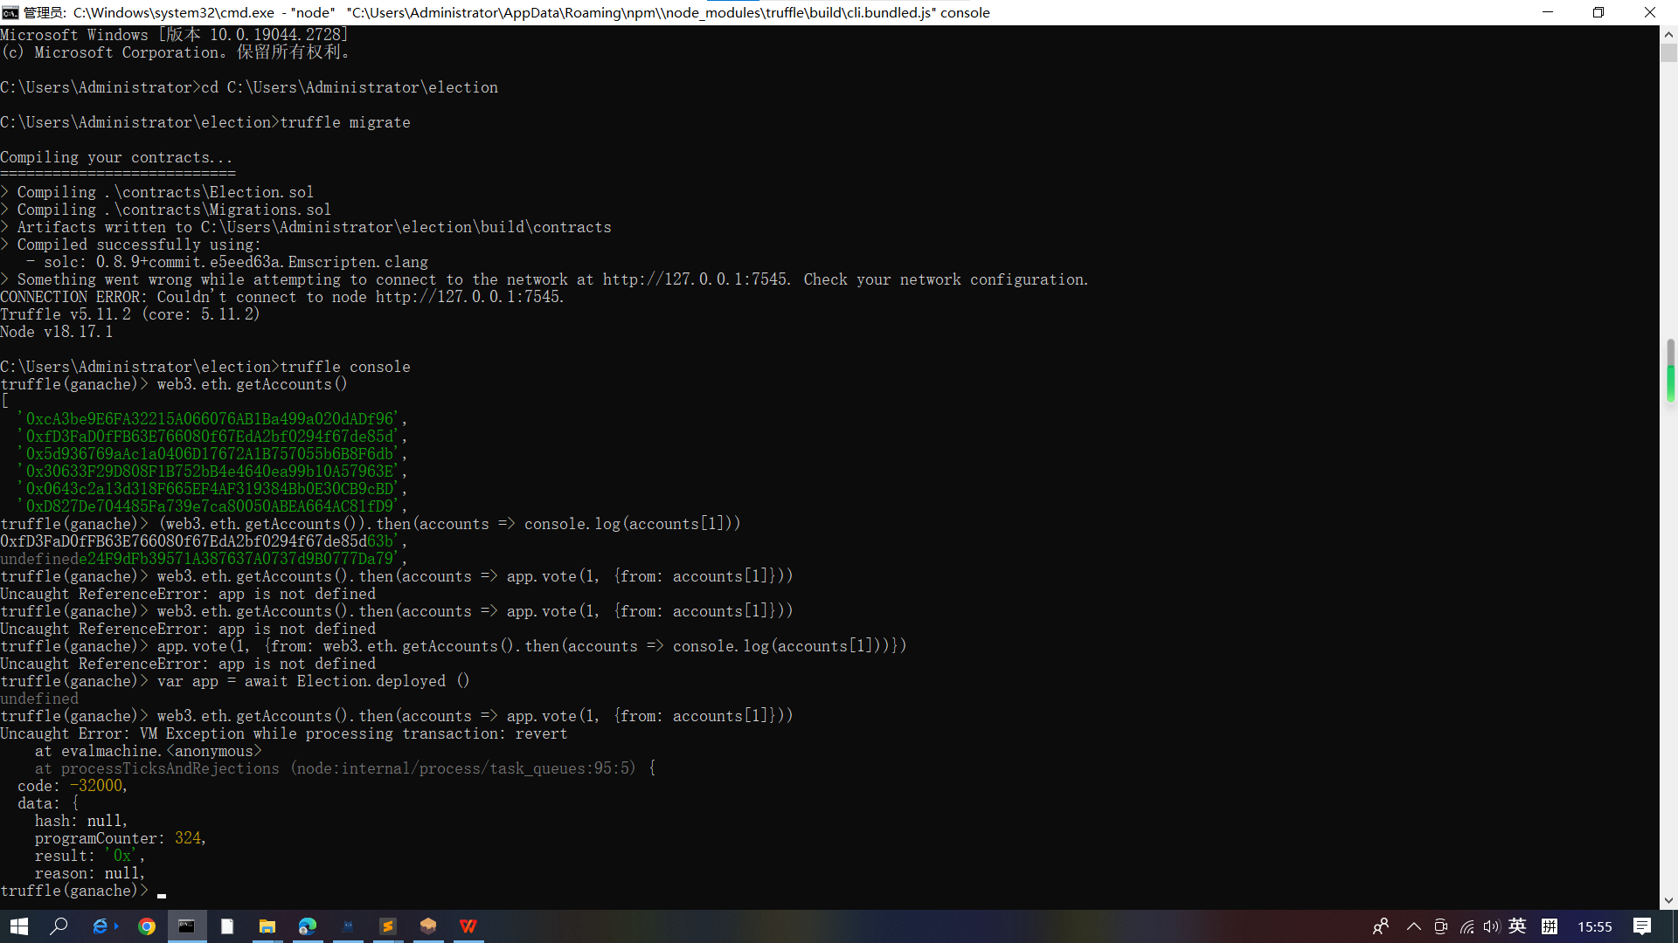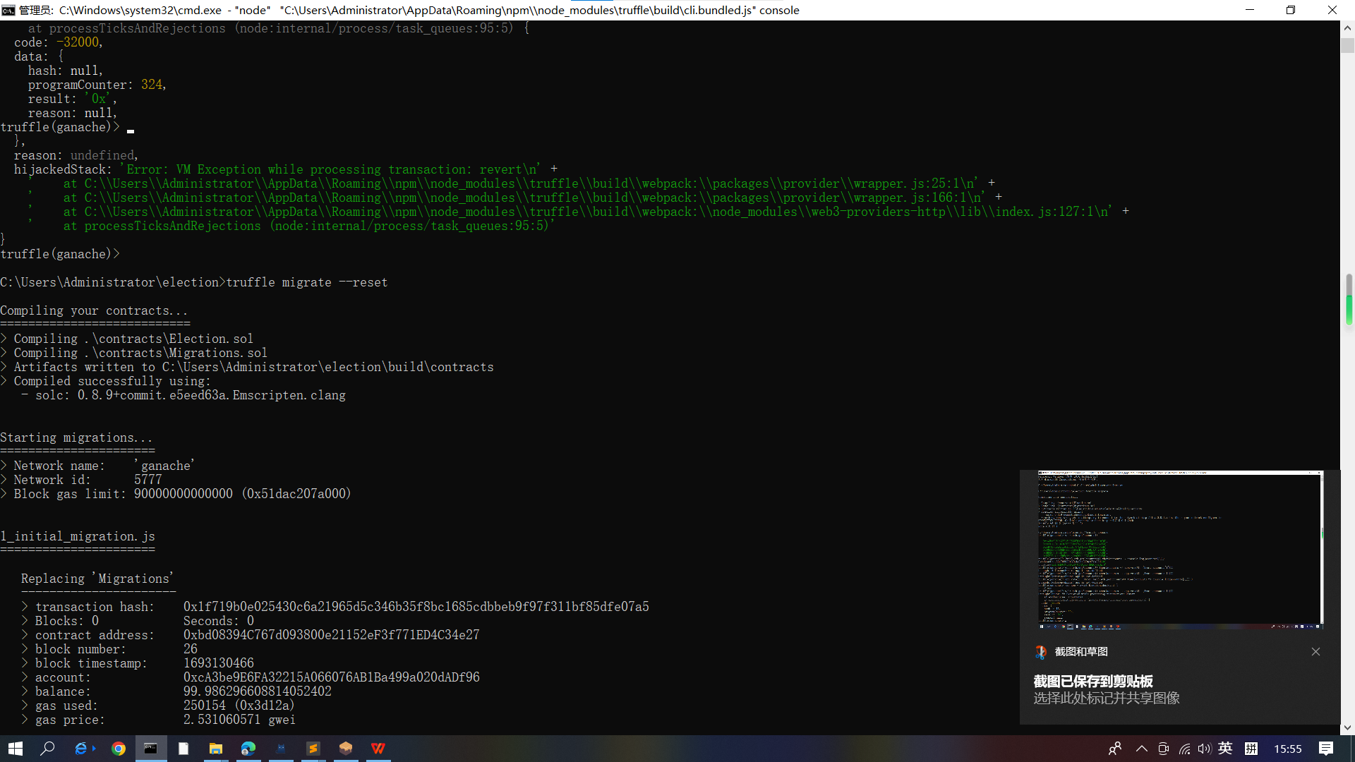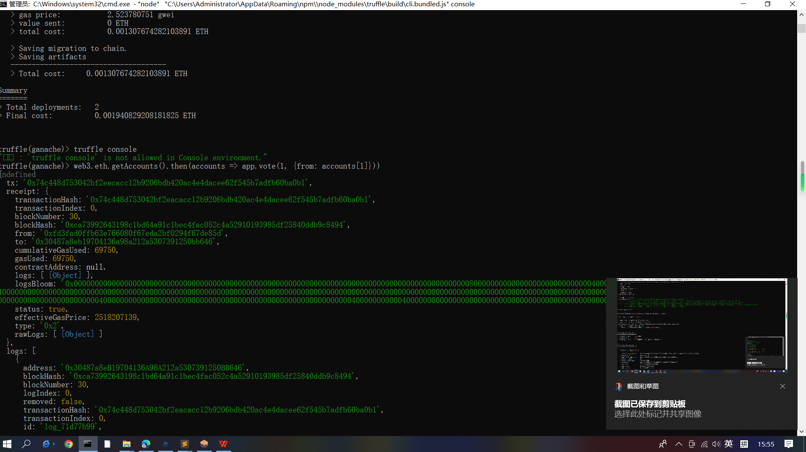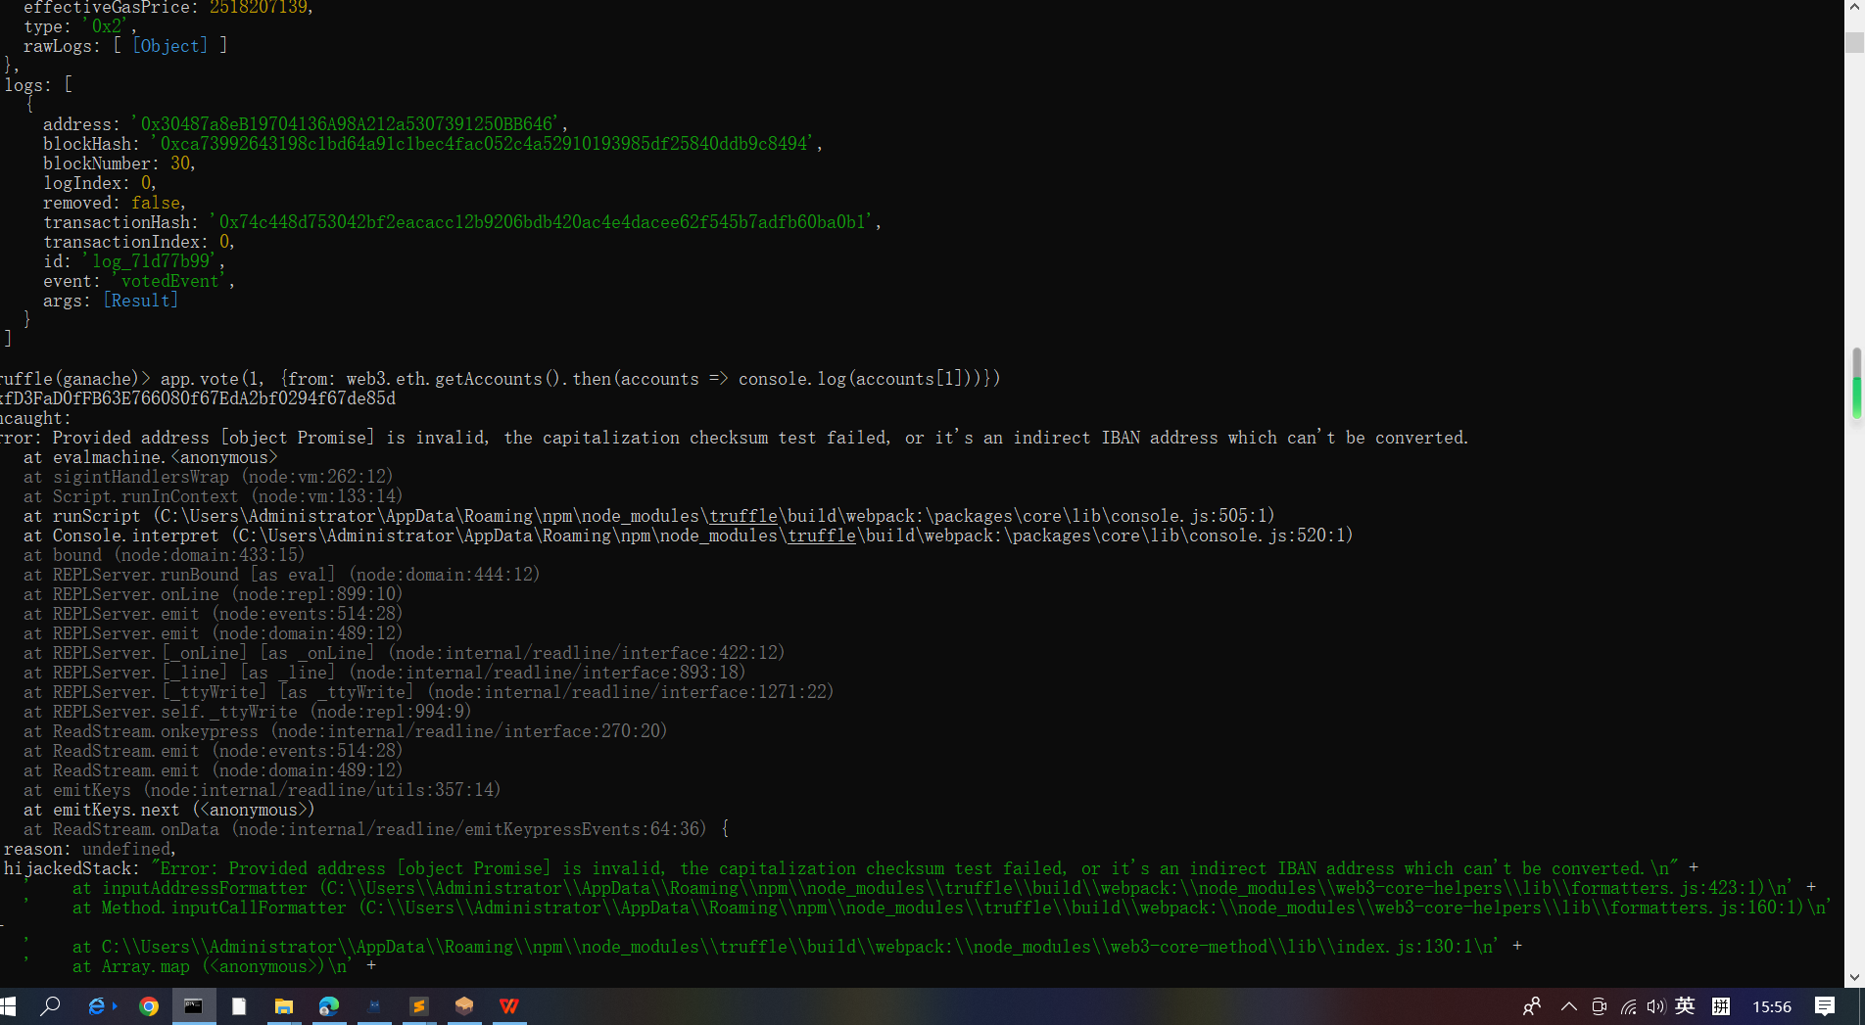web3.eth.getAccounts().then(accounts => app.vote(1, {from: accounts[1]}))
备份
const Election = artifacts.require("./Election.sol");

contract("Election", function(accounts) {
let electionInstance;

it("initializes with two candidates", async function() {
electionInstance = await Election.deployed();
const count = await electionInstance.candidatesCount();
assert.strictEqual(count.toNumber(), 2);
});

it("it initializes the candidates with the correct values", async function() {
const candidate1 = await electionInstance.candidates(1);
assert.strictEqual(candidate1[0].toNumber(), 1, "contains the correct id");
assert.strictEqual(candidate1[1], "Candidate 1", "contains the correct name");
assert.strictEqual(candidate1[2].toNumber(), 0, "contains the correct votes count");
const candidate2 = await electionInstance.candidates(2);
assert.strictEqual(candidate2[0].toNumber(), 2, "contains the correct id");
assert.strictEqual(candidate2[1], "Candidate 2", "contains the correct name");
assert.strictEqual(candidate2[2].toNumber(), 0, "contains the correct votes count");
});
});
it("allows a voter to cast a vote", function() {
return Election.deployed().then(function(instance) {
electionInstance = instance;
candidateId = 1;
return electionInstance.vote(candidateId, { from: accounts[0] });
}).then(function(receipt) {
return electionInstance.voters(accounts[0]);
}).then(function(voted) {
assert(voted, "the voter was marked as voted");
return electionInstance.candidates(candidateId);
}).then(function(candidate) {
var voteCount = candidate[2];
assert.equal(voteCount, 1, "increments the candidate's vote count");
})
});
最终代码const Election = artifacts.require("./Election.sol");

contract("Election", function(accounts) {
let electionInstance;

it("initializes with two candidates", async function() {
electionInstance = await Election.deployed();
const count = await electionInstance.candidatesCount();
assert.strictEqual(count.toNumber(), 2);
});

it("it initializes the candidates with the correct values", async function() {
const candidate1 = await electionInstance.candidates(1);
assert.strictEqual(candidate1[0].toNumber(), 1, "contains the correct id");
assert.strictEqual(candidate1[1], "Candidate 1", "contains the correct name");
assert.strictEqual(candidate1[2].toNumber(), 0, "contains the correct votes count");
const candidate2 = await electionInstance.candidates(2);
assert.strictEqual(candidate2[0].toNumber(), 2, "contains the correct id");
assert.strictEqual(candidate2[1], "Candidate 2", "contains the correct name");
assert.strictEqual(candidate2[2].toNumber(), 0, "contains the correct votes count");
});

it("allows a voter to cast a vote", async function() {

electionInstance = await Election.deployed();

candidateId = 1;

await electionInstance.vote(candidateId, { from: accounts[0] });

const voted = await electionInstance.voters(accounts[0]);

assert(voted, "the voter was marked as voted");

const candidate = await electionInstance.candidates(candidateId);

var voteCount = candidate[2];
assert.equal(voteCount, 1, "increments the candidate's vote count");
});
});
GPTBEIWANGLU
备忘录
你好，这是Bing。我看到你在使用JavaScript语言来编写和运行智能合约的测试用例。你的代码看起来很不错，但是我有一些建议可以帮助你改进它：
- 你可以使用async/await语法来简化你的代码，让它更容易阅读和理解。async/await语法可以让你用同步的方式写异步的代码，避免回调地狱。例如，你可以把你的最后一个测试用例改写成这样：
it("allows a voter to cast a vote", async function() {
// 部署合约，并返回一个Promise对象
electionInstance = await Election.deployed();
// 定义一个变量来存储候选人的id
candidateId = 1;
// 调用合约的vote方法，传入候选人的id和from参数，从accounts数组中选择第一个账户地址作为投票者
await electionInstance.vote(candidateId, { from: accounts[0] });
// 调用合约的voters方法，传入投票者的地址，获取投票者的信息
const voted = await electionInstance.voters(accounts[0]);
// 断言投票者的信息为true，表示已经投过票
assert(voted, "the voter was marked as voted");
// 调用合约的candidates方法，传入候选人的id，获取候选人的信息
const candidate = await electionInstance.candidates(candidateId);
// 断言候选人的投票数等于1，表示已经收到了一票
var voteCount = candidate[2];
assert.equal(voteCount, 1, "increments the candidate's vote count");
});
Copy
- 你可以使用const或let关键字来声明你的变量，而不是var关键字。const和let关键字可以让你更好地控制变量的作用域和赋值，避免潜在的错误和混乱。例如，你可以把你的第一个测试用例中的var关键字改成const或let关键字：
it("initializes with two candidates", async function() {
// 使用const关键字声明electionInstance变量
const electionInstance = await Election.deployed();
// 使用const关键字声明count变量
const count = await electionInstance.candidatesCount();
assert.strictEqual(count.toNumber(), 2);
});
Copy
- 你可以使用箭头函数来定义你的测试用例，而不是普通函数。箭头函数可以让你的代码更简洁和优雅，而且可以避免this指针的问题。例如，你可以把你的第二个测试用例中的普通函数改成箭头函数：
it("it initializes the candidates with the correct values", async () => {
const candidate1 = await electionInstance.candidates(1);
assert.strictEqual(candidate1[0].toNumber(), 1, "contains the correct id");
assert.strictEqual(candidate1[1], "Candidate 1", "contains the correct name");
assert.strictEqual(candidate1[2].toNumber(), 0, "contains the correct votes count");
const candidate2 = await electionInstance.candidates(2);
assert.strictEqual(candidate2[0].toNumber(), 2, "contains the correct id");
assert.strictEqual(candidate2[1], "Candidate 2", "contains the correct name");
assert.strictEqual(candidate2[2].toNumber(), 0, "contains the correct votes count");
});
Copy
我希望这些建议能帮助你改进你的代码。如果你想要了解更多关于JavaScript语言的知识，你可以参考一些我为你找到的网页搜索结果：
- [JavaScript 教程 - w3school.com.cn]：一个教程网站，介绍了JavaScript语言的基本概念和语法。
- [JavaScript | MDN]：一个文档网站，提供了JavaScript语言的详细参考和示例。
- [Learn JavaScript - Free Interactive JavaScript Tutorial]：一个交互式教程网站，让你通过练习和测试来学习JavaScript语言。
祝你编程愉快！
Election.deployed().then(function(i) { app = instance })
Kali linux

备份
const Election = artifacts.require("./Election.sol");

contract("Election", function(accounts) {
let electionInstance;

it("initializes with two candidates", async function() {
electionInstance = await Election.deployed();
const count = await electionInstance.candidatesCount();
assert.strictEqual(count.toNumber(), 2);
});

it("it initializes the candidates with the correct values", async function() {
const candidate1 = await electionInstance.candidates(1);
assert.strictEqual(candidate1[0].toNumber(), 1, "contains the correct id");
assert.strictEqual(candidate1[1], "Candidate 1", "contains the correct name");
assert.strictEqual(candidate1[2].toNumber(), 0, "contains the correct votes count");
const candidate2 = await electionInstance.candidates(2);
assert.strictEqual(candidate2[0].toNumber(), 2, "contains the correct id");
assert.strictEqual(candidate2[1], "Candidate 2", "contains the correct name");
assert.strictEqual(candidate2[2].toNumber(), 0, "contains the correct votes count");
});

it("allows a voter to cast a vote", async function() {

electionInstance = await Election.deployed();

candidateId = 1;

await electionInstance.vote(candidateId, { from: accounts[0] });

const voted = await electionInstance.voters(accounts[0]);

assert(voted, "the voter was marked as voted");

const candidate = await electionInstance.candidates(candidateId);

var voteCount = candidate[2];
assert.equal(voteCount, 1, "increments the candidate's vote count");
});
it("throws an exception for invalid candidates", function() {
return Election.deployed().then(function(instance) {
electionInstance = instance;
return electionInstance.vote(99, { from: accounts[1] })
}).then(assert.fail).catch(function(error) {
assert(error.message.indexOf('revert') >= 0, "error message must contain revert");
return electionInstance.candidates(1);
}).then(function(candidate1) {
var voteCount = candidate1[2];
assert.equal(voteCount, 1, "candidate 1 did not receive any votes");
return electionInstance.candidates(2);
}).then(function(candidate2) {
var voteCount = candidate2[2];
assert.equal(voteCount, 0, "candidate 2 did not receive any votes");
});
});
it("throws an exception for double voting", function() {
return Election.deployed().then(function(instance) {
electionInstance = instance;
candidateId = 2;
electionInstance.vote(candidateId, { from: accounts[1] });
return electionInstance.candidates(candidateId);
}).then(function(candidate) {
var voteCount = candidate[2];
assert.equal(voteCount, 1, "accepts first vote");
// Try to vote again
return electionInstance.vote(candidateId, { from: accounts[1] });
}).then(assert.fail).catch(function(error) {
assert(error.message.indexOf('revert') >= 0, "error message must contain revert");
return electionInstance.candidates(1);
}).then(function(candidate1) {
var voteCount = candidate1[2];
assert.equal(voteCount, 1, "candidate 1 did not receive any votes");
return electionInstance.candidates(2);
}).then(function(candidate2) {
var voteCount = candidate2[2];
assert.equal(voteCount, 1, "candidate 2 did not receive any votes");
});
});
});

改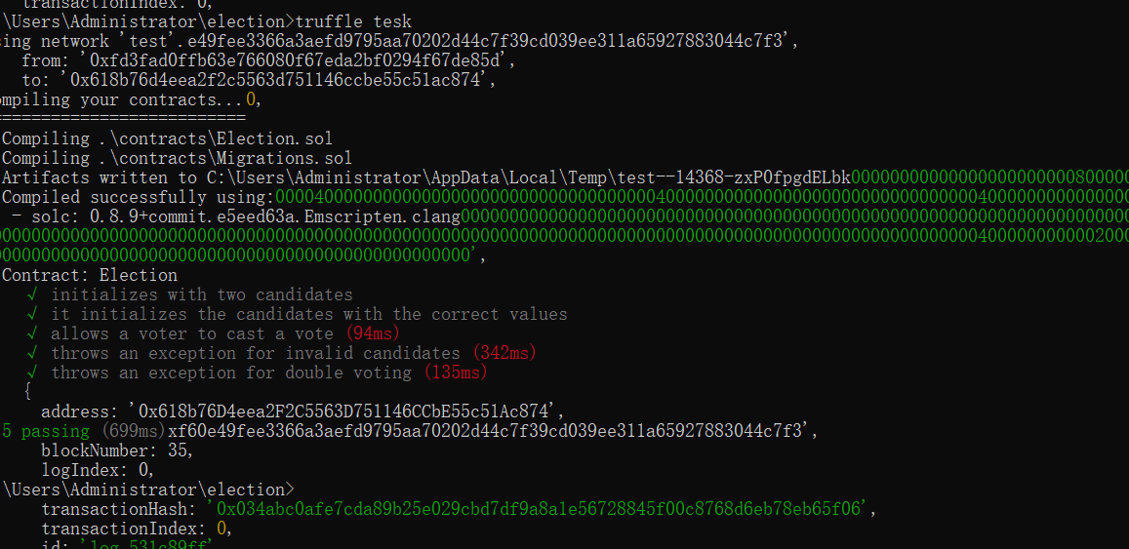
const Election = artifacts.require("./Election.sol");

contract("Election", function(accounts) {
let electionInstance;

it("initializes with two candidates", async function() {
electionInstance = await Election.deployed();
const count = await electionInstance.candidatesCount();
assert.strictEqual(count.toNumber(), 2, "contains the correct candidates count"); // 加上错误信息
}); // 加上分号

it("it initializes the candidates with the correct values", async function() {
const candidate1 = await electionInstance.candidates(1);
assert.strictEqual(candidate1[0].toNumber(), 1, "contains the correct id"); // 加上分号
assert.strictEqual(candidate1[1], "Candidate 1", "contains the correct name"); // 加上分号
assert.strictEqual(candidate1[2].toNumber(), 0, "contains the correct votes count"); // 加上分号
const candidate2 = await electionInstance.candidates(2);
assert.strictEqual(candidate2[0].toNumber(), 2, "contains the correct id"); // 加上分号
assert.strictEqual(candidate2[1], "Candidate 2", "contains the correct name"); // 加上分号
assert.strictEqual(candidate2[2].toNumber(), 0, "contains the correct votes count"); // 加上分号
}); // 加上分号

it("allows a voter to cast a vote", async function() {

electionInstance = await Election.deployed();

candidateId = 1;

await electionInstance.vote(candidateId, { from: accounts[0] });

const voted = await electionInstance.voters(accounts[0]);

assert(voted, "the voter was marked as voted"); // 加上分号

const candidate = await electionInstance.candidates(candidateId);

var voteCount = candidate[2];
assert.equal(voteCount, 1, "increments the candidate's vote count"); // 加上错误信息
}); // 加上分号

it("throws an exception for invalid candidates", async function() { // 使用async/await语法
electionInstance = await Election.deployed(); // 使用await关键字
try {
await electionInstance.vote(99, { from: accounts[1] }); // 使用await关键字
assert.fail(); // 抛出失败断言
} catch (error) {
assert(error.message.indexOf('revert') >= 0, "error message must contain revert"); // 捕获错误并断言
}
const candidate1 = await electionInstance.candidates(1); // 使用await关键字
var voteCount = candidate1[2];
assert.equal(voteCount, 1, "candidate 1 did not receive any votes"); // 加上错误信息
const candidate2 = await electionInstance.candidates(2); // 使用await关键字
var voteCount = candidate2[2];
assert.equal(voteCount, 0, "candidate 2 did not receive any votes"); // 加上错误信息
}); // 加上分号

it("throws an exception for double voting", async function() { // 使用async/await语法
electionInstance = await Election.deployed(); // 使用await关键字
candidateId = 2;
await electionInstance.vote(candidateId, { from: accounts[1] }); // 使用await关键字
const candidate = await electionInstance.candidates(candidateId); // 使用await关键字
var voteCount = candidate[2];
assert.equal(voteCount, 1, "accepts first vote"); // 加上错误信息
// Try to vote again
try {
await electionInstance.vote(candidateId, { from: accounts[1] }); // 使用await关键字
assert.fail(); // 抛出失败断言
} catch (error) {
assert(error.message.indexOf('revert') >= 0, "error message must contain revert"); // 捕获错误并断言
}
const candidate1 = await electionInstance.candidates(1); // 使用await关键字
var voteCount = candidate1[2];
assert.equal(voteCount, 1, "candidate 1 did not receive any votes"); // 加上错误信息
const candidate2 = await electionInstance.candidates(2); // 使用await关键字
var voteCount = candidate2[2];
assert.equal(voteCount, 1, "candidate 2 did not receive any votes"); // 加上错误信息
}); // 加上分号

}); // 加上分号

